**Problem Statement:**

**Objective:** To understand the concept of inheritance.

**Problem Description:** A construction company wants to keep a record of the employees working in it. There are permanent employees as well as contract employees. Contract employees work on an hourly basis whereas permanent employees are paid monthly salary. The class diagrams are as given below:

**Employee:**

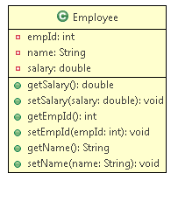

**A record of the employee name, salary, and the employee Id has to be maintained for each employee.**

**PermanentEmployee:**

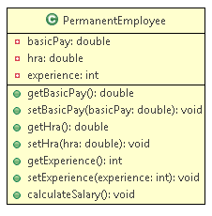

**Method Description:**

* calculateSalary():This method calculates the salary using the formula as given below:

**Salary = variable component + Basic pay +HRA**

The condition for calculating **variable component** is given below:

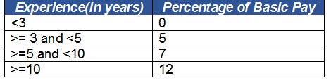

**ContractEmployee:**

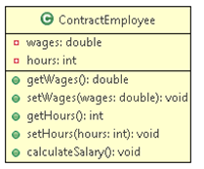

**Method Description:**

* calculateSalary():This method calculates the salary using the formula as given below:

**Salary = total hours * wages**

**Implementation Details:**

* Create a class EmployeeRecords and implement the main method:

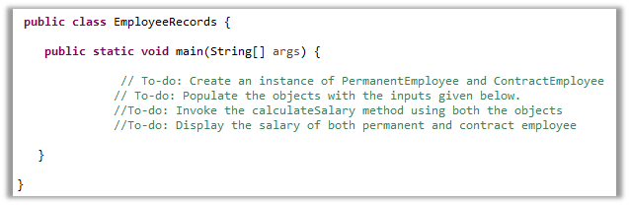

Provide the following inputs:

**Input (For PermanentEmployee):**

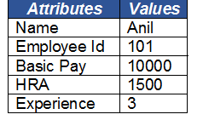

**Output:**



**Input (For ContractEmployee):**

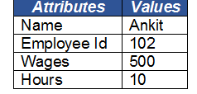

**Output:**



* Observe how you can call the setter and getter method of salary of Employee class using an instance of both Permanent as well as Contract Employee.

